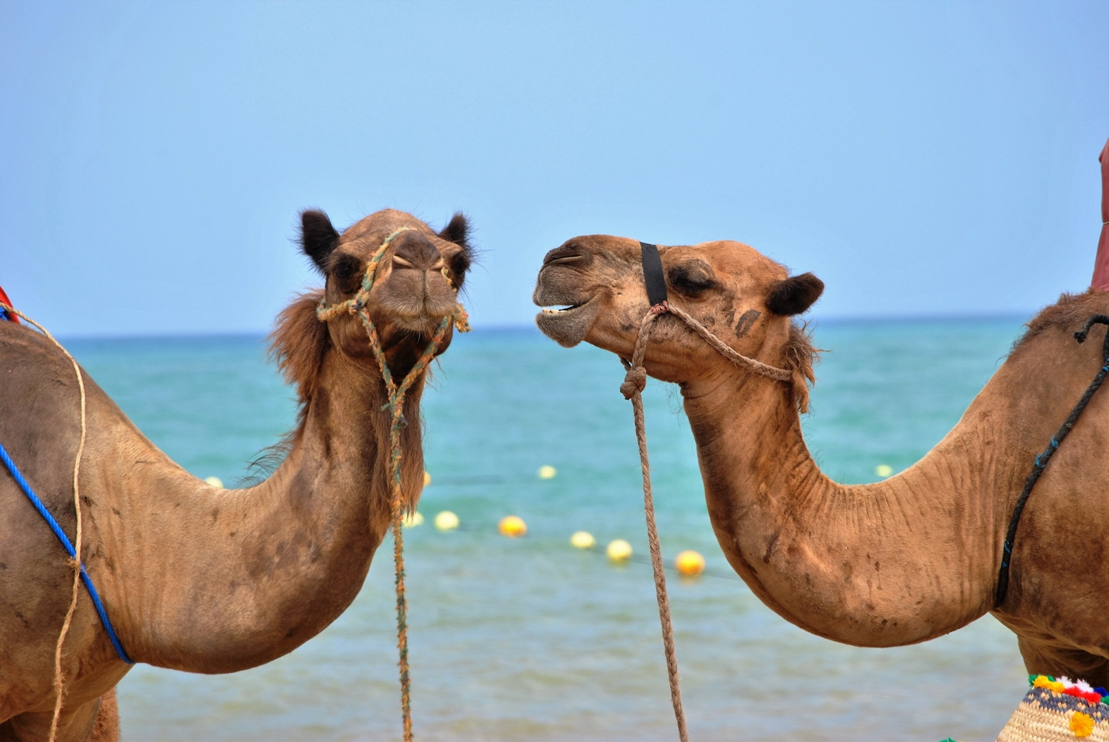
Photo by Kawtar CHERKAOUI on Unsplash.com

- Share something about your personal life
  - Hobby
  - Humorous or Interesting Story
  - Something few people know about you
  - Other?

- How do you measure success in your mediations?

- What is # 1 on your bucket list?

- What has been your best moment this year?

- What do you need to do to take your practice/skills to the next level?

